11 The Transformer

This chapter covers
- Transforming text to tokens
- Attention mechanisms
- Encoders and decoders
- Decoding strategies
Please ignore grammar errors and typos. What you see is a raw manuscript; it has not been copyedited.
All throughout this book, you have been using language models as “black boxes”. But what’s actually happening inside? This and the next chapter are for you if you have started to get a little curious as to how language models work internally. At the same time, knowing more about the underlying mechanisms can help you to use those models more efficiently.
This chapter introduces the Transformer, currently by far the most popular neural network architecture for language models. All the models we’ve been using in this book so far, including GPT as well as alternatives by other providers, implement the Transformer architecture. This chapter discusses the Transformer at a fairly high level of abstraction (after all, you probably don’t want to create your own Transformer model but are content with using it) as well as the pre and post-processing steps that are needed to use Transformer models for all the various tasks we have seen in prior chapters. Section 11.1 introduces a pre-processing step, used to transform text input to a numerical representation. This representation is suitable as input for the actual language model. Section 11.2 discusses the basic building block of the Transformer architecture. Sections 11.3 and 11.4 present two popular variants of the Transformer model, both commonly used for language models. Finally, Section 11.5 describes the process by which we obtain output text from Transformer models in more detail. Altogether, this chapter will give you a good understanding of how language models work internally.

11.1 Tokenization
Think back to your conversation with ChatGPT in . Whenever you enter text, be it a friendly greeting or specific instructions, the very first thing that happens with it is a pre-processing step, called “tokenization”. In this section, we will have a closer look at what tokenization is and how it works.

11.1.1 What is tokenization?
So what happens during tokenization? As we all know, computers are good at processing bits and bytes, i.e., numbers. The goal of tokenization is to transform your input text into something the computer, more precisely the language model, can work with: a sequence of numbers. Those numbers are called the “tokens”.
The component that performs tokenization is, as one might expect, called the “tokenizer”. E.g., let’s assume we are saying hello to ChatGPT with a friendly “Hi there!”. The tokenizer used by GPT transforms this text into the token sequence 15496, 612, 0 (this situation is illustrated in Figure 11.1). In this specific case, each token represents either one word or one punctuation mark. However, as we will discuss later, this is not always the case. Also, different language models use different tokenizers. Given the same input, the number of output tokens as well as the token IDs may differ across different tokenizers!

Figure 11.1 The tokenizer transforms input text into a sequence of tokens (i.e., integer IDs).
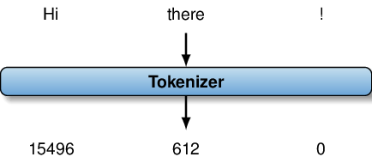

Up - understood

11.1.2 Why tokenization is difficult
Why is tokenization even difficult? Can’t we just assign one token ID to each letter in the alphabet, then tokenize text letter by letter? Well, we could do that but, assuming we are using a language like English (where each word consists of many letters), it’s probably not a good idea. Transformer models are generally limited to a maximal number of tokens they can process (and, without going into detail, it becomes more and more costly to use models that support longer sequences of tokens with high accuracy). Hence, making tokens represent single letters means we can only represent a relatively short amount of text, using a fixed token limit. Hm, so what else can we do?
Another idea is to make tokens represent single words. To elaborate a bit more: let’s assume we have a fixed vocabulary of tokens, each representing one word (and associated with a unique ID), then we can map a text to tokens, word by word. We simply iterate over words, look up the associated ID in our vocabulary, then add the token ID to our token sequence. And, of course, this means we can represent a much longer text than before with the same number of tokens! Sounds pretty good so far? It does. And that is why this approach, in many variants, has actually been used to represent text for quite a while. Modern models like GPT have however opted for different tokenization strategies. Why? Well, because there are a few problems with the one token-one word approach. What problems might we encounter here? Anyone?
The problem is the vocabulary. A tokenizer uses a fixed vocabulary that is chosen before model training starts. After training a model, it is now specialized to the vocabulary used by the tokenizer. Expanding the vocabulary requires retraining the model (which is very expensive). Of course, we can simply take a dictionary, make each word within it a token, and then hope that we never need to change it anymore (or, at least, not anytime too soon since dictionaries, same as language, gradually change over time). But what about names? What about long numbers, dates, words in a foreign language, misspelled words, and, possibly, composite words? Handling such cases is difficult when using a dictionary where each token represents an entire word. Just considering names alone (of persons, places, etc.): it is simply not feasible to include all possibilities in advance into a fixed token vocabulary. Seeing enough text after choosing our vocabulary, we are bound to encounter words for which we have no token IDs eventually.
Can we recover from that, somehow? Well, we can certainly try. Among the most popular strategies is the following one. We reserve a special token, often called the “unknown” token, that is used whenever we encounter a word not included in our vocabulary. This is not very convenient, however: for the model, it is not very informative to know that an unusual word was encountered. This makes it hard to solve associated tasks, e.g., trying to translate a text with unknown tokens into another language. Clearly, this is not an ideal strategy. But what else can we do, given that we do not want to go back to associating tokens (exclusively) to single characters again?

11.1.3 How GPT tokenizes text
The solution used by GPT and similar models is to use tokens to represent letters, words, and word parts, all together! This is the most flexible approach, among all the ones we discussed before. Tokens are neither constrained to represent single letters nor are they constrained to represent entire words anymore. This means, we can use tokens to represent common words while switching to tokens representing smaller units of text (in the extreme case, single letters) to represent names and other less common strings as multiple, instead of single, tokens. Sounds great! But how do we choose which tokens to include into our vocabulary? Here, we will not go too much into detail as the vocabulary construction process is not immediately relevant as long as you’re merely using existing models. But, at a high level of abstraction, models typically use a vocabulary that has been generated automatically, given a large collection of sample text documents as input. Given that sample text, we can automatically detect frequent sequences of letters that are probably worth representing as a single token (typically, with the goal of minimizing the number of tokens needed to represent text passages).
For instance, GPT uses a method called byte-pair encoding that is based on this principle, using an iterative merging process to generate tokens representing more and more characters, until a fixed number of tokens have been generated. You don’t need to understand the details of this process but know that tokens may represent words, letters, or something in between. For instance, if configuring GPT to use certain words more often, each word may correspond to multiple tokens, or to one single token. Also, know that the precise tokens have been determined automatically based on a set of sample documents. If training models to do well on different types of text (e.g., either natural language or code), it makes sense to vary the vocabulary as well. For instance, have a look at https://platform.openai.com/tokenizer where you will find the OpenAI tokenizer. At the time of writing, you find two different tokenizers, one specialized for representing program code, the other one specialized for representing text. When configuring models to use specific tokens, make sure to use the right tokenizer to translate text into token IDs (since, otherwise, you will not get the effect you’re aiming for).
Enough talk about tokenization! For the following, we can now imagine that we are processing a sequence of tokens that represent words or smaller units of text. The user input, as well as the system output, is internally represented via such token sequences. When receiving text input from the user, we use tokenization to map text to tokens. When generating output for the user, we use the inverse process to translate tokens back into words.
Any comments on section 11.1 Tokenization?

Up – well explained, great idea to refer reader to tokenization web site, it helped reinforce the concepts

11.2 Attention mechanisms
So how do we process tokens? And why does a Transformer process them better than prior methods? To explain what a Transformer is and how it processes tokens, we must first discuss a bit about a key idea that makes the Transformer model so cool. That key idea is called an attention mechanism.
To get a first idea of what attention mechanisms are about, let’s consider an example. The following two sentences are taken from the laptop review that we analyzed in : “I bought the BananaBook a year ago and I’m super happy with this product! It’s fast enough for everything I want to do with it, e.g., coding, office work.” The second sentence starts with a pronoun (“it”). How do we attach semantics to that? By relating it to other words in the same review. Here, obviously, it refers to the BananaBook laptop, mentioned in the first sentence. How do we make that determination? Well, we consider properties of the words we’re attaching semantics to (“it”) as well as properties of other words in the same review, including their position and semantics. BananaBook appears in the sentence before the pronoun, it’s a noun and its semantics (BananaBook sounds like a laptop, doesn’t it?) matches the activities described in the second sentence. Very roughly, that’s what attention mechanisms are about: these mechanisms change our “perception” of a word (or, rather, token) by relating it to other words (or tokens) in the same text.

11.2.1 Queries, keys, and values
To understand attention mechanisms in more detail, we need to understand three terms: query, key, and value, in the context of attention mechanisms and understand how they interact. And because this is a book for data scientists, we will try to understand them by an analogy to data processing systems. First of all, let’s have another look at those terms: query, key, and value. Does that ring a bell? Any data management solutions that relate to them? How about key-value stores? Let’s see. Well, certainly we’re also talking about queries, keys, and values in a key-value store. As a little reminder: a key-value store stores values (which could be arbitrary objects) associated with keys. Storing data is boring, we also want to retrieve it! And, indeed, a key-value store also allows retrieving data by issuing queries. The key-value store compares the query to the keys, associated with stored values, and returns the values associated with matching keys. Typically, keys and queries are formulated as strings and key and query match if it is the same string. Sounds familiar? You may already have used (or are currently using) popular key-value stores such as Redis, Memcached, or DynamoDB. But what do they have to do with attention mechanisms and Transformers?
Well, first of all, we have seen that key-value stores and attention mechanisms happen to use the same key terms. But the similarities don’t stop there! It turns out that the semantics of those terms, query, key, and value, is actually quite similar when comparing those two. Sure, there are various differences and the following explanation is simplifying. But still, let’s get simplified mental picture of attention mechanisms first, using the analogy to key-value stores, then discuss why it’s simplifying, and finally try to make our mental picture of attention mechanisms more realistic!
So, let’s start our highly simplifying explanation of attention mechanisms. Similar to a key-value store, an attention mechanisms associates values with keys. Then, given queries, it retrieves for each query the values associated with matching keys. In summary, according to this simplifying picture, an attention mechanism works exactly like a key-value store! But where do those queries, keys, and values actually come from? Well, our ultimate goal is to process sequences of tokens. Hence, it makes sense that queries, keys, and values are associated with tokens. More precisely, in the simplest case, each token in a given sequence (one that we want to process) is associated with one query, one key, and one value. But how do we know which tokens to assign to which query, key, and value? That part is actually difficult and this is where hours, days, or weeks of model training are needed to learn automatically, how to map tokens to queries, keys, and values. We postpone the discussion of training methods to ???? .

11.2.2 A detailed example
First of all, let’s make all of that a little more concrete. Figure 11.2 illustrates our current (highly simplifying) mental picture of attention mechanisms by a little example. Let’s assume we’re considering the token representing the sequence “the BananaBook. It” (an extract from our laptop review again). In this specific case, each word is represented by one token (but we have seen, in the previous section, that this is not necessarily the case!). Now, as discussed so far, we associate one query, key, and value with each token. Note that this is only one specific variant of attention mechanisms (called, more precisely, self-attention). We will see other variants later that associated keys, queries, and values not with tokens from the same but from different token sequences. For now, we associate all three of them with the same tokens and Figure 11.2 represents all of them as symbols, namely stars, rectangles, diamonds, and circles (in reality, each of the three, queries, keys, and values, correspond to high-dimensional vectors). Each row of symbols corresponds to a different component of the attention mechanism (starting from the bottom: values, keys, and queries) and different columns are associated with different tokens (shown in the lowest row). As discussed, we currently assume that attention mechanisms work, pretty much, like key-value stores. For instance, to obtain the output for the last token (“It”), we first look at the query (a star), then compare that query with all keys to find that only the token “BananaBook” is associated with a star key as well. Next, we retrieve the value associated with that token (a circle) and use it as output. Note that the output refers to the token issuing the query (“It”), not to the token providing the value (“BananaBook”).
To get the hang of it, cover the upper row and try to predict the right output for each token yourself. Not too bad, is it? As long as we abstract away quite a few of the nitty-gritty details behind attention mechanisms, we are using the same process as a key-value store. So how is our current explanation simplifying? Well, quite in a few different ways, actually. First of all, we’re not dealing with discrete symbols but rather with high-dimensional vectors. The precise number of dimensions differs across different Transformer models but dimensions in the hundreds or thousands of vector components are rather typical. Second, we have so far assumed a binary matching function. Either it’s the same symbol or not! That’s not what we use in a real attention mechanism. Instead, real Transformers use a continuous matching function, i.e., we capture the degree of similarity (a continuous number), rather than a binary result. The similarity function is based on the distance between the query and the key vectors. Third, so far, we have assumed that the output contains input values as-is (and, conveniently, our example assumes that no query matches more than a single key). In reality, we calculate the output vector rather by a weighted sum over the value vectors, weighted by the similarity between query and keys. This still means that the attention mechanism prioritizes values associated with keys that approximately match the query. But, as we use a continuous similarity function, the result won’t be due to a single value anymore, but rather to a combination of values, some of them more important than others.

Embeddings
Real attention mechanisms process vectors associated with tokens. However, tokenization (discussed in the previous section) translates text into a sequence of (discrete) numbers. At this point, you may be wondering how we got from discrete numbers to vectors in the first place. The answer is a process called “Embedding” that maps token IDs to high-dimensional vectors after tokenization. We will not discuss the embedding process in detail (since you will deal with token IDs, rather than vectors, when configuring language models). However, you will often come across that term when reading up on language models so it’s good to know what it refers to.
=[compL0, minimum width=1cm, minimum height=1cm, blur shadow=shadow blur steps=5]

Figure 11.2 Illustrating a simplified variant of attention mechanisms: each column is associated with one word and the per-column output is obtained as the value associated with the key matching the corresponding query. E.g., query “star” in the forth column matches key “star” in the second column with associated value “circle” (which therefore becomes the output for the second column).
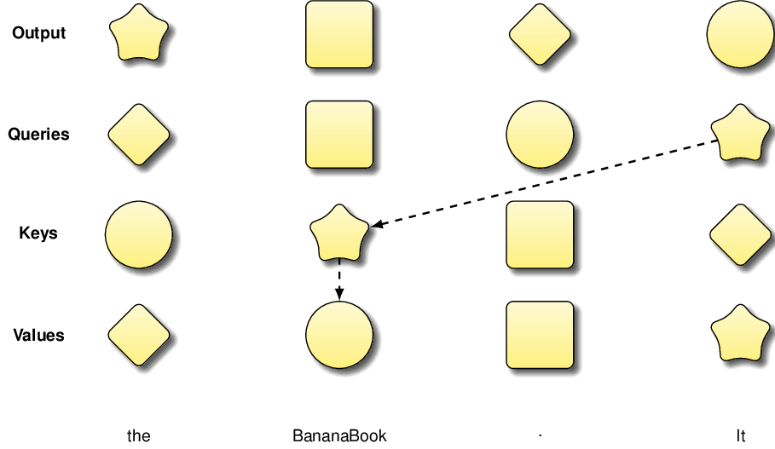

Up - understood

11.2.3 What makes attention mechanisms special?
So why is everyone so excited about those attention mechanisms? How is this better than what was used before (and what was that again)? To get a first sense for what makes attention mechanisms interesting, think back to where you “calculated” the output in Figure 11.2 by matching queries with keys. Does the order of tokens in which you calculated the output matter? No, it does not. Since we don’t need the output of any token to calculate outputs of other tokens, we are free to use any order you like. But, more importantly, imagine you have a few friends who help with the “daunting” task of calculating outputs for specific tokens. If you and your friends work together, you could assign one person to each token and obtain the full output much faster! Clearly, you see where this is going. Attention mechanisms make it quite easy to parallelize the calculation of outputs across different tokens. Prior methods for processing sequence input of variable length would often calculate the output for the next token by exploiting output for the previous token. This means we have to process tokens in precisely the order in which they are given and cannot parallelize as easily. Given current hardware trends, leading to devices like GPUs with higher and higher degrees of parallelism, being able to parallelize computations more easily is an important advantage. Reusing output from prior tokens also has other potential drawbacks. For instance, any mistake we make during the process will propagate if reusing prior output, possibly exacerbating its effects, with each new token. This can make it harder to handle long sequences of tokens reliably. All of these points are merely giving a rough idea for why Transformer models are so popular. Most importantly, in empirical evaluations, it has been shown that Transformer models, based on such attention mechanisms, work significantly better than prior methods for a variety of text processing tasks. Note that Transformer models were not the first to use attention mechanisms. However, Transformer models were the first to rely almost exclusively on attention mechanisms in all their computation. This means that they fully benefit from all of the aforementioned advantages of attention mechanisms.
Do we have the full picture now? Well, not really. Real attention mechanisms are quite a bit more complex than what we have discussed. But what we have seen so far, provides you with a solid understanding for how attention mechanisms work. This will enable you to understand the following sections, building on top of attention mechanisms to explain how different types of Transformer models, in particular encoders and decoders, work.
Any comments on section 11.2 Attention mechanisms?

? challenging to understand, required many re-reads, more examples might help

11.3 Encoders
Ok, we did it! We discussed all of the basics, namely tokenization and attention mechanisms, we need to actually dive into what a Transformer is. Let’s first focus on what is, arguably, the simplest version of a Transformer: an encoder-only model. We will then expand our scope to different types of Transformers in the following sections. Some model providers, for instance Huggingface (see https://www.huggingface.co/), give you the choice between different Transformer architectures (including encoder and decoder models). To make such choices, you must first understand what both of them are!

Figure 11.3 Simplified architecture of encoder-only Transformer: input is transformed by a chain of attention mechanisms.
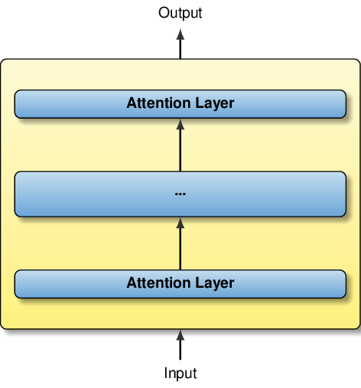

Up -understood

11.3.1 Encoder architecture
Have a look at Figure 11.3: it illustrates the high-level architecture of an encoder-only Transformer model. Of course, this figure is highly simplifying but it gets the following point across: Transformer models rely heavily on attention mechanisms (so that’s the reason why we discussed them before!) and they don’t only use a single one but a whole bunch of them! Those attention mechanisms are actually chained, meaning that the output of one is used as input for the next one. The component in the middle (labeled with three dots) represents a whole chain of attention mechanisms (e.g., several tens of layers are nowadays typical). Note that this figure is highly simplifying and omits quite a lot of details (e.g., additional layers in between the attention mechanisms). The goal here is to give you merely the big picture. This won’t suffice if you want to build your own Transformer models but it should definitely suffice as long as you just want to use existing models!

11.3.2 Multi-Head Self-Attention
More precisely, the attention layers depicted in Figure 11.3 implement a specific type of attention mechanism: multi-head self-attention. Different Transformer models use different types of attention mechanisms. To understand the differences between them, we should have a closer look at what that means. So what is multi-head self-attention? Let’s break that down a bit.
Self-attention means that keys, values, and queries all refer to tokens from the same sequence (which is exactly the situation depicted in Figure 11.2).
What might the alternative be? As we discuss in more detail later, an alternative would be a mechanism that associates those components with tokens taken from different sequences. But no: the encoder model, illustrated in Figure 11.3, merely calculates output by “looking up” values associated with tokens whose keys are similar to the query associated with the current token, all within different tokens of the same sequence!
But we’re not only talking about self-attention, it’s “multi-head self-attention”, to be precise. What does the first part refer to?
Each multi-head attention layer contains not one but multiple attention mechanisms (“heads”).
Why do we need multiple attention mechanisms? Well, intuitively, when analyzing text we may be interested in many different types of dependencies between tokens. For instance, for verbs, we may want to link them to associated subjects, for pronouns, we may want to link them to their associated nouns. These examples may serve to give a first impression for why having several attention mechanisms, in each layer, is useful. In reality, the functionality realized by different attention mechanisms is not as clearly defined as in those examples, it is often hard to develop a good understanding for the function realized by a specific attention mechanism at a specific layer of the encoder stack. As discussed in more detail in ???? , the configuration for each attention mechanism is not specified but emerges gradually during the training process.
Ok, so that’s the encoder model for you (see Figure 11.3): you have a chain of layers, each associated with multiple attention mechanisms, that transform the Transformer input into the output. The input is a sequence of vectors, each representing a token. The raw output is a sequence of vectors, the output of the final attention layer of the Transformer. Alternatively, we can add a post-processing stage in which those final output vectors are transformed into class labels (e.g., if we want to map an input text, such as a review, to a sentiment) or into markers indicating the start and end of a relevant text snippet (e.g., a snippet containing the answer to a question, also part of the input text).

11.3.3 Visualizing attention
The concept of a Transformer model may seem a little abstract at the beginning. What helps in those cases is to look at some visualizations, explaining what’s going on inside of the Transformer for a concrete input. In the following, we will have a closer look at one specific, encoder-only Transformer model: BERT.

BERT - isn’t that the one from Sesame Street?
Indeed it is! But that’s not the BERT we’re talking about here. Instead, BERT abbreviates Bidirectional Encoder Representation with Transformers. It’s an encoder model and it does use the Transformer architecture. Bidirectional representation distinguishes BERT from prior models that use only part of the input to calculate the output associated with one specific token. Whereas BERT, when calculating the output associated with one specific token, can use information taken from tokens to the left and to the right of it (bidirectional), prior models were only able to use information from one side but not from both. To get all the details on BERT, have a look at the full paper introducing the model.

Figure 11.4 Google CoLab notebook for visualizing attention mechanisms inside of BERT, a popular language model: replace the marked-up string with sentences of your choice and re-run all cells to visualize attention for different inputs!
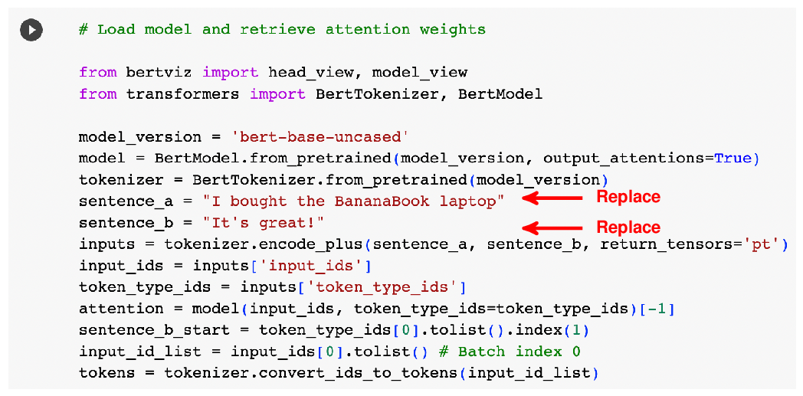

Up - understood
The following experiments use the BertViz tool which you can download¹ and install locally or, which may be simpler, use the pre-configured notebook online (you find the link on the corresponding project page). Figure 11.4 shows the corresponding online notebook. No need to understand each line of code within it but know that we are visualizing dependencies between two input sentences that you can configure yourself (simply by replacing values for the two variables sentence_a and sentence_b that you see in the figure). We will use the two sentences “I bought the BananaBook laptop” and “It’s great!”, inspired by our review example, in the following. BERT can be used to perform various tasks on this input, e.g., determining whether the review expresses satisfaction or dissatisfaction with the product (we used GPT for that in ). In ????, we discuss how BERT can be specialized for different tasks. Independently of the specific task, BERT processes inputs via a chain of attention mechanisms. In the following, we will see a few visualizations that illustrate how those attention mechanisms work internally.

Figure 11.5 Visualizing similarity between queries and keys, associated with pairs of tokens from the same token sequence.
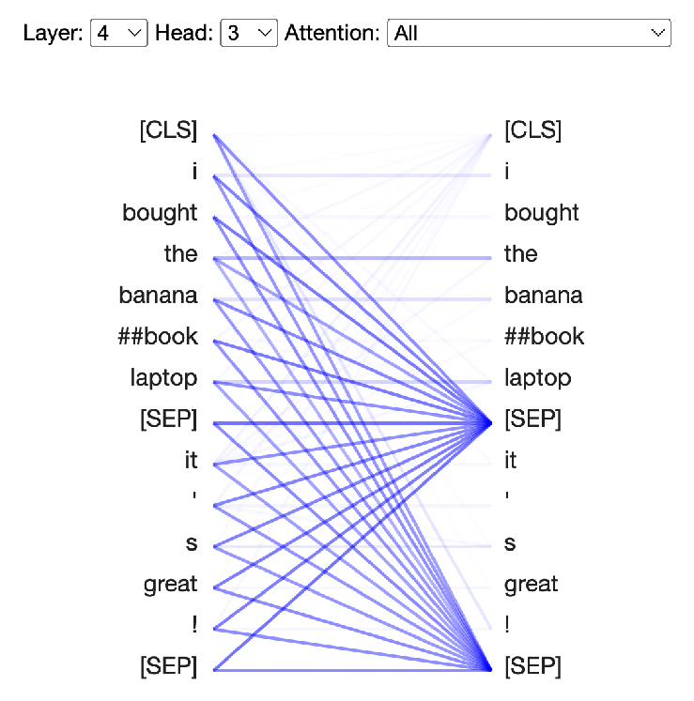

Up - understood
As mentioned previously, BERT is an encoder model and uses a chain of multi-head self-attention mechanisms to perform its magic! We’re talking about self-attention here, so queries, keys, and values all refer to the same input tokens. In this case, those input tokens represent the concatenation of the two aforementioned input sentences. As each token is associated with a query, as well as with a key and a value, we can visualize the similarity between queries and keys, considering any pair of tokens. The visualization in Figure 11.5 (which you find in the “Neuron View” section of the notebook) visualizes similarity between pairs of tokens, shown to the left and to the right of the plot. The strength of the blue lines, connecting token pairs, represents the strength of the similarity (i.e., token pairs with matching queries and keys are drawn in a bright blue).
You may note that BERT automatically inserted a few special characters that don’t appear in our original input. Specifically, you will find a [CLS] token at the beginning of the input and [SEP] tokens between the two sentences and at the very end. Those tokens have a special semantics and indicate the start of the input and of the corresponding sentences. Sometimes, BERT wants to represent information that relates to one of the input sentences (or to the pair of them) as a whole, e.g., the result of a sentence classification task. In those cases, it makes sense to associate that information with a generic token that does not depend on the specific sentence content. Also, note that most tokens represent entire words or punctuation marks. The word “BananaBook”, however, is mapped to multiple tokens as it is not part of the standard vocabulary. In this case, following the tokenization technique described in Section 11.1.3, BERT’s tokenizer decomposes the word into two tokens that relate to common words.
Of course, you can visualize all the attention mechanisms that you find in a BERT model. See the two little drop-down menus at the left upper corner of the visualization? Here you can select the layer as well as the head (the specific attention mechanism within the layer) that you want to visualize. Try out a few different attention mechanism to get a sense for whether or not the different attention mechanisms are similar. Spoiler: they typically aren’t! If you visualize enough attention mechanisms, you will probably get a whole lot of visualizations that tend to look quite different from each other. The whole point of having so many different attention mechanisms within the same model is to realize lots of different attention functions that are useful for language processing.

Figure 11.6 Visualizing all attention mechanisms within the BERT Transformer model: different rows correspond to different layers and different columns correspond to different heads within the same layer. The visualizations in each cell correspond to a miniature version of the one shown in Figure 11.5.
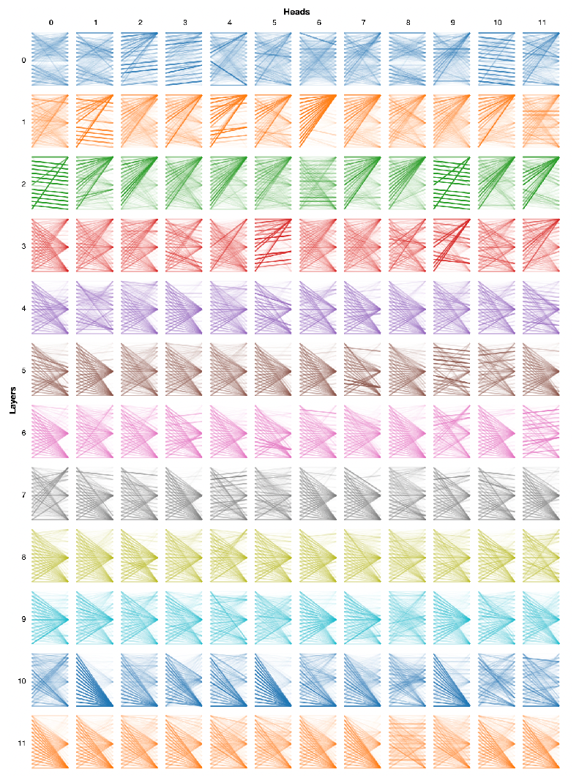
Up - understood
If you don’t like to click around a lot and prefer seeing all attention mechanisms at once - no problem, we got you covered! Have a look at the “Model View” section of the notebook. Here, you should see something similar to Figure 11.6: a two-dimensional matrix, one dimension covering the different layers (the y-axis or rows) while the other dimension covers different heads within the same layer (that one is the x-axis or columns). Each cell contains a mini-version of the visualization in Figure 11.5, representing the similarity between keys and queries of different tokens.

Figure 11.7 Detailed view of similarity values and the vectors, based on which they are calculated. The middle columns represent, from left to right, the query and key vector, then the component-wise vector product and its sum.
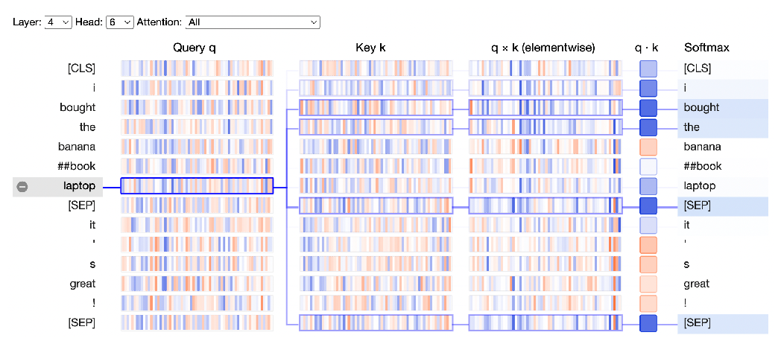

Up - understood

11.3.4 Visualizing attention in more detail
Let’s now finally dive down a bit deeper into why we have different similarity values between different token pairs. For that, we go back to the first visualization (the “Neuron View”, shown in Figure 11.5). We are now looking at one specific attention mechanism and will try to understand how we get to those similarity values that are shown in the picture. Let’s click on the little plus sign, shown next to any of the tokens in the two input sequences, to get more details. You should now see something resembling Figure 11.7. Compared to the first version, the visualization has expanded quite a bit (horizontally) to show a high-level representation of the queries and keys associated with each of the tokens. Note that we don’t get any additional information on the values: they don’t matter for the calculation of the similarity values (which is what this visualization is about)!
Between the two copies of the input sequence, we now see four columns. From left to right, this is a representation of the query vector, the key vector, the component-wise product between those two vectors, and the sum of the component-wise products (that last column does not represent an entire vector, rather an aggregate, and is therefore much more narrow than the other three).
Queries and keys correspond to high-dimensional vectors, making it hard to represent them in all detail. The visualization uses the following representation: on the horizontal axis, we have different vector dimensions, colors indicate the associated values. The color blue is associated with positive values and the color red is associated with negative values. The stronger the color, the higher the absolute values in both directions. You will find that similar queries and keys, having red and blue bands at the same positions, correlate with a higher similarity value. That’s how it is supposed to work: the similar vectors get high aggregate values.
Feel free to play with the notebook a bit, try out different visualizations and different input sentences! We only discussed a subset of the features and it’s well worth having a closer look at the notebook and familiarizing yourself with the BertViz tool. By now, we have at least a high-level idea of what an encoder-only Transformer really is. But are encoder-only models sufficient? In the next section, we discuss about another model, the so-called decoder, and about the situations in which you really need it.
Any comments on section 11.3 Encoders?

? - This is a lot to digest in one reading. I think I get the general idea, but tough to fully comprehend without more examples and visualizations. For the sake of time, I continue and maybe revisit later.

11.4 Decoders

Figure 11.8 Simplified architecture of Transformer decoder.
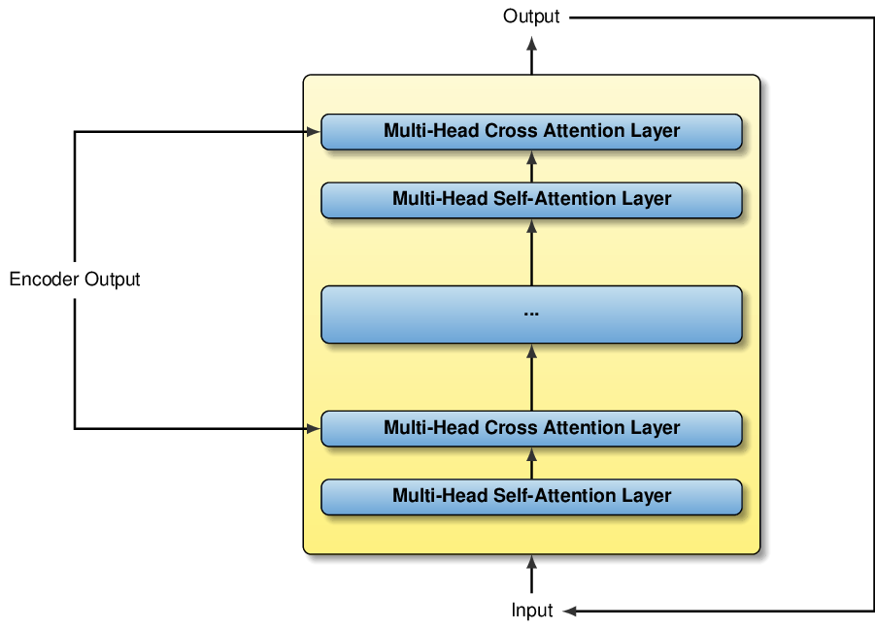

Up - understood
So, encoders seem great! Why do we need something else?

11.4.1 Why we need decoders
Let’s think back to our conversation with ChatGPT in . Models like ChatGPT try to come up with a reasonable reply for a very wide range of inputs. For instance, we tested its generic conversation skills, its ability to classify text, or to write SQL queries. The fact that we expect the model to solve such a wide range of problems leads to many challenges. One of those challenges lies in the fact that the length of an optimal answer may vary between different tasks and it does not necessarily relate to the input length!
Now that is tricky if we want to use encoder-only models like BERT. BERT encodes the input into a pre-determined number of output vectors, making it convenient to use for tasks such as token classification (e.g., assigning tokens to word categories), sentence classification (assigning entire sentences or sentence pairs to classes, typically based on the output vector associated with the first, the [CLS] token), or answer extraction (determining the start and end of the answer from the output vectors associated with each token). But it doesn’t really work for “free-form” text generation where the size of the output text may greatly vary between inputs, without being proportional to the input length!

11.4.2 Decoder architecture
This is where encoder-decoder (or even decoder-only) models shine! GPT is, in fact, a decoder model. Next, we’ll discuss about how those decoders work internally and why they are good for tasks where encoder models tend to fail. Have a look at Figure 11.8. It shows the high-level architecture of an encoder-decoder model (the encoder has been omitted, as we have already seen it in Figure 11.3, and is merely represented as one of the inputs to the decoder). Same deal as for our picture illustrating encoders (Figure 11.3): the architecture is largely simplified, omits lots of details, and merely serves to give you rough mental picture for how decoders work.
What it does show, however, is a chain of attention layers (again) that transform the input to the output. So, first impression, this is not too different from the encoder, is it? Let’s have a closer look. A first difference to the encoder is the fact that we have now two different types of attention mechanisms. First of all, we have “Multi-Head Self-Attention”. That one, we already know from the encoder (see Section 11.3.2). But what about “Multi-Head Cross Attention”? Let’s break that term down and understand how the latter differs from the former.

11.4.3 Cross versus self-attention
We already know about the first term, “Multi-Head”: similar to encoders, having one single attention mechanism per layer is just not enough so we want to have multiples! But what is “Cross Attention”? So far, we have been mostly discussing about “Self-Attention”. Remember the definition? Self-attention means that all components of the attention mechanism, namely queries, keys, and values, are associated with tokens of the same input sequence. Cross attention, however, is different.
For cross attention, queries are associated with tokens in one sequence whereas keys and values are associated with tokens from a different sequence.
In case of the decoder, depicted in Figure 11.8, queries are associated with tokens in the decoder input, whereas keys and values are associated with the encoder output. Hence, this attention mechanism is “crossing” the line between encoder and decoder. Intuitively, it enables the decoder to query the output of the encoder.
So, that’s what cross attention is about: we enable the decoder to integrate information gained by the encoder. As shown in Figure 11.8, the self-attention and cross attention layers alternate in the decoder. This enables the decoder to integrate insights about connections between tokens in the decoder input with information gained by analyzing the encoder input. But wait: what’s the difference between encoder and decoder input? Don’t we have a single input that we want to process?

11.4.4 Turning output into input
We will come back to that question in a minute. But first, let’s have another look at Figure 11.8. Perhaps one of the most crucial differences to the encoder is the line connecting the decoder output to the decoder input! What does this mean? In the simplest case (and we will discuss variants in the next section), it means the following: to generate the full output, e.g., a witty reply by ChatGPT, we perform multiple steps. In each step, we use the decoder to generate one single output token. Now, if we don’t change the input to the decoder (nor the encoder input), we would eternally generate the same output token, that’s clearly not what we want! So, instead, we simply inform the decoder on the last generated tokens by adding them to the input for the next step. That way, the decoder sees partially generated input and (in the ideal case) “knows” precisely which token should be generated next! Now, we simply keep generating tokens until specific tokens appear that indicate the end of the desired output (as shown in , you can specify those termination tokens yourself in a problem-specific manner).

Autoregression
The approach of using output from prior time steps as (part of) the input for the following steps is called autoregression. Models using this approach are also called autoregressive models. You will come across those terms frequently when reading descriptions of language models.
So, in the case described before, the decoder input contains partial output, generated in previous time steps. So, for instance, if our goal is to translate text from English to French, we can use the English text to translate as encoder input. Then, starting from an empty string, the decoder input contains parts of the French translation, generated in prior token generation steps. That answers the question about how encoder and decoder inputs differ for this specific task.

Table 11.1 Generating output with a decoder: each step produces one output token that we append to the input for the next step.
1 | Hello GPT! | Hello
2 | Hello GPT! Hello | user
3 | Hello GPT! Hello user | !
4 | Hello GPT! Hello user! | [STOP]
Up - understood

11.4.5 Decoder-only models
Finally, note that we may not even need an encoder. In fact, language models based on the Transformer tend to implement one of three variants: encoder-only, decoder-only, or an encoder-decoder architecture. For instance, BERT (which we discussed in the previous section) is a pure encoder model. That means we want to avoid using it for tasks where the output length is variable (relative to the input length). On the other side, BART and T5 (which stands for the text-to-text transfer transformer!) are encoder-decoder models and therefore quite flexible. But do we really need an encoder at all? Can’t we just use the user request as initial decoder input, then add generated tokens in each time step until the output is complete? Perhaps we can, at least that’s what GPT is doing. GPT is a decoder-only model and directly generates output, using input that combines the user request and partial output.
Table 11.1 illustrates this process by an example. Each row represents one time step, the table shows the input and the output token. Starting from the user input (“Hello GPT!”), the model produces an output token in the first step (“Hello”), then appends that token to the input in the next step. That step produces the output “user”, which is added to the input for the next step and so on. The whole process terminates once a dedicated token (“[STOP]”), indicating termination, is generated. While it is common, note that there are variants of this method that use the decoder differently. We’ll discuss more about them in the next section.
Ok, we did it! You now have a high-level picture of what encoders and decoders are, and how they relate to each other. This should provide you with some first insights into why we want to use specific architectures for certain tasks (which is useful to select between different models once you have the choice!). Model alternatives are often described by properties such as the number of layers or the number of heads. Knowing a little bit about the Transformer architecture enables you to make sense of such descriptions.
Any comments on section 11.4 Decoders?

? – Again, this is a lot to digest in one reading. I think I get the general idea, but tough to fully comprehend without more examples and visualizations. For the sake of time, I continue and maybe revisit later.

11.5 Decoding strategies
The last section omits a whole lot of details about how a decoder generates output. You may think that you can get away not knowing all of the nitty-gritty details on how that process works. But, in this case, you may be wrong! It turns out that Transformer models such as GPT come with a lot of tuning parameters. Web interfaces like the one we used in tend to use default settings for those parameters without allowing users to make changes. But to get optimal performance, using the more sophisticated interfaces discussed , you want to use optimal settings for your specific scenario. As many of those parameters relate to the process by which the decoder generates output, it’s well worth having a closer look and discussing the most important output generation strategies. That’s what we will do in the following.

11.5.1 A simple decoding strategy
Ok, first of all: in the last section, we talked about using the decoder to generate one output token per time step. How does that actually work? Going a little bit more into detail (but, on the other side, not too much either), the output of the decoder, ultimately high-dimensional vectors, can be transformed into scores associated with each possibility for the next token. The higher the score, the higher the preference for the corresponding token. So that’s not too bad, is it? We can just select the token with the highest score in each time step and concatenate the resulting text, right? Yes, indeed, we can do that. But there are a few reasons why we might not want to.
The simple approach described above is what we will call the greedy approach in the following. So what’s wrong with the greedy approach? First of all, there are cases where selecting the token with the highest score is actually not what you want to do. Language models are imperfect and may get the scores wrong from times to times. For instance, using the greedy approach, GPT may translate your natural language request into an SQL query that does not quite execute when submitted to the database management system (e.g., trying to execute that query may throw an error due to an incorrect table name). What do we do in such cases? Re-generating output with the greedy approach is not promising. The language model would simply generate the same (wrong) output again. Hence, for this and other reasons, we need a mechanism that allows us to deviate from the options with the highest scores. We need a certain degree of randomization.

11.5.2 Randomizing output via the temperature parameter
Fortunately, interfaces for language models like GPT give you the option to add a bit of randomness into the process. That means you will typically get slightly different output, each time you invoke the decoder model. Typically, the relevant parameter is called the temperature. To give you a little bit of background: we discussed about the scores that the model associates with each token (indicating the preference for this token). We can transform those scores into a probability distribution (i.e., essentially, per-token scores that sum to one when considering all tokens). That operation is called a “softmax”, by the way. Now, we could just select the next token randomly, using the aforementioned probability distribution to determine the probability to be selected for each token. At least, this means that tokens with higher scores have a higher probability to be selected (which is typically what we want). However, it’s a little bit inflexible as we cannot choose the degree of randomization (e.g., whether it is likely or not so likely that we don’t select the token with the highest score). This is where the temperature comes into play.
The temperature influences the probability distribution we use for sampling when selecting the next token. Using the temperature, we can choose whether to sample using the score-based probability distribution, or whether we want to change that distribution. In essence, the temperature determines how much we want to base our probability distribution on the per-token scores (the “raw” decoder output). In the extreme case, we can assign a probability of 100% to the token with the highest score and a probability of 0% to all the other tokens. This can be achieved using a temperature of zero. You will notice that this corresponds precisely to the greedy approach, discussed before. On the other hand, if we choose a higher temperature, we can move the distribution away from that extreme and closer to a uniform probability distribution (where every token would have the same probability of being selected, independently from the score).
Quite often, neither extreme is interesting. For instance, many GPT versions use a default temperature of 0.7. That’s not quite the greedy approach but not that far from it either. It means you will likely get different output when invoking the model with the same input repeatedly but, typically, it won’t be drastically different. If our goal is to get around slightly incorrect output, produced with a temperature of zero, that may be just what we want. On the other hand, in some cases, we may want to get deterministic output. For instance, if classifying text, we cannot easily recognize if one solution is better than another one (at least not automatically, different from trying to execute an SQL query and getting an error). Here, it may be better to choose a temperature of zero. A common approach is to vary the temperature in consecutive model invocations, using the same input. You start with a temperature of zero and, if whatever you get is not what you want, you increase the temperature in the next invocation until, with enough randomization, you hopefully get the solution you’re looking for.

Figure 11.9 Illustrating the path from raw per-token scores to the selection of the next output token.
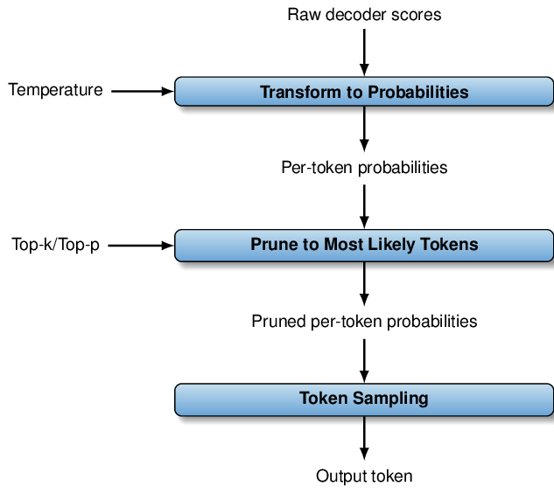

Up - understood

11.5.3 Other parameters for randomization
Temperature is typically not the only parameter you have to influence the way output tokens are generated. For instance, you may want to get randomization via sampling while not deviating too much from the tokens with the highest scores. But that’s challenging since, due to the large number of tokens, the accumulated probability of sampling any of the highly unlikely tokens may still be large in aggregate! This is where top-k and top-p sampling come to the rescue. But what is that precisely? Top-k and top-p sampling are both methods that essentially “prune” the probability distribution over output tokens by discarding the ones with the lowest probabilities. They do so in slightly different ways. Let’s start with top-k sampling. For top-k sampling, we prune out all but the k (k is an integer) most likely tokens, i.e., we set the probability of all other tokens to zero (and adapt the remaining probability values accordingly to make sure they still sum up to one). Top-p sampling also discards all but some of the most likely tokens. However, this time, the number of tokens to keep is not explicitly given. Instead, we have p, and p is a probability. So, given p, we keep adding tokens in decreasing order of likelihood, until the total probability (i.e., the probability sum) of all selected tokens reaches p. Then, we discard the remaining tokens. Web interfaces such as the one by OpenAI offer you the possibility to use top-p or top-k sampling.
Ok, time for a little summary! Have a look at Figure 11.9. It summarizes the different decoding strategies we have discussed so far. In general, we start with per-token scores, produced by the decoder (preferred tokens have higher scores). First of all, we can transform scores into a probability distribution. The transformation is influenced by the temperature. A lower temperature means tokens with high scores are a lot more likely than tokens with lower scores. A higher temperature means scores matter less and we’re making the distribution more uniform. Also, we can prune the probability distribution by discarding tokens with low probability. We have seen two alternative methods to do that: selecting the k most likely tokens or selecting enough tokens such that their aggregate probability sums up to a value p. Finally, we use the resulting per-token probabilities for sampling and select the next output token.

Figure 11.10 Search space for answer generation: tokens with associated probabilities (in parenthesis).
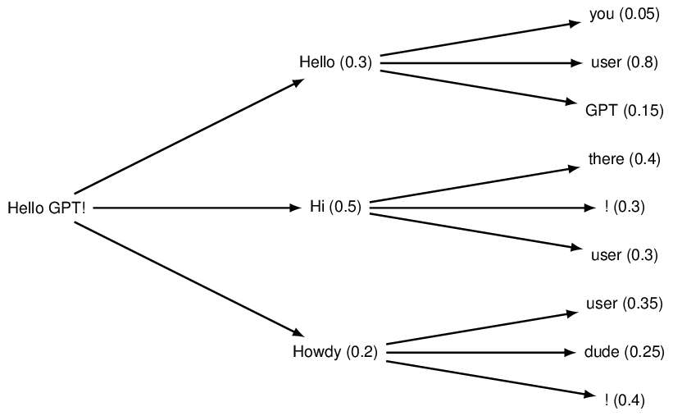

Up - understood

11.5.4 Thinking multiple steps ahead
So far, we have discussed ways to introduce randomization when selecting the next output token. That helps in cases where the highest scoring token is not actually the best one (i.e., the decoder got it slightly wrong). But is that the only problem? What if our scores are perfect, can we get an optimal output text using the greedy algorithm, i.e., by selecting the token with the highest score in each step? It turns out: the answer is no. Let’s have a look at an example to get a better sense for what might go wrong. Figure 11.10 illustrates the search space for a text completion as a tree. In this example, the user has entered “Hello GPT!”. Now, GPT is thinking hard to come up with a witty reply. Figure 11.10 illustrates the range of possibilities as a tree: each possible output text corresponds to a path from the root of the tree (on the left side) to one of the leaf nodes (on the right side). Each tree node is labeled by a token (to keep things simple, we assume that each token corresponds to a word or punctuation mark), followed by a number (which we discuss next). To get the text associated with a path from the root to a leaf, we simply concatenate the corresponding tokens. For instance, always selecting the upper-most node in each step yields the output text “Hello you” (which may not be the preferred output).
As mentioned previously, each node is labeled with a token and a number (in parenthesis). Time to discuss the second component. The number is a probability, taken from the probability distribution we discussed previously. You might notice that, for each node, probabilities of child nodes sum up to one in each case. This means the tokens shown in the picture cover all possibilities the model considers. You might wonder whether that’s a realistic search space size: it’s absolutely not! In reality, a model would consider ten thousands of tokens in each step (except if using pruning). However, we want to keep things simple to make the example easier to “parse”. Now, we have the probability of a single token, given directly in the figure. But what about the aggregated probability of a sequence of tokens? Do we add up the probability values we encounter on the path? Close, but not quite. Instead, we take the product of probabilities to assess the quality of the entire text completion. For instance, for the path discussed before (“Hello you”), we get an accumulated probability of
(rather on the lower side if we compare with some of the other options). Now, we have set the stage, it’s time to show how the greedy algorithm fails in this example!
Imagine what the greedy algorithm would do. Starting from the root node on the left, representing the user input, the greedy algorithm would first select “Hi” (probability 0.5), then “there” (probability 0.4). What’s the accumulated probability? Again, we take the product, and that makes ????
. Wow, that’s much better than “Hello you” with probability 0.015! But is it really optimal? Not so much: have another look and consider the option “Hello user”. What’s the probability? The probability for the first token is 0.3 (well, that’s slightly disappointing) but then we have a probability of 0.8 (wow, that’s much better than before!). In total, that makes a probability of ????
. So that’s the best possible completion overall (have a look at Table 11.2, comparing the example completions we discussed so far)!
So what went wrong? Why didn’t the greedy algorithm find the optimal completion? It always strives to select the best completion in each step, doesn’t it? Indeed, it does. But that’s not enough: the greedy algorithm is myopic, in a sense, and only “thinks” about the next step, not the long-term perspective! Let’s illustrates this by a real-world example. You could lay down this book now and play a computer game instead (or whatever your favorite activity is!). But, down the line, you may spend more time than you like to, trying to write tricky SQL queries instead of having GPT do most of the hard work for you (which leaves more time for computer games)! Take this example with a grain of salt (we’re biased here, after all), but you see where we are going: again, we’re talking about the difference between a short-term and a long-term perspective. Better to optimize for the long term and that’s what the greedy algorithm is not doing!

Table 11.2 Example completions from Figure 11.10 and their associated probabilities.
Hello you | 0.3 | 0.05 | 0.015
Hi there | 0.5 | 0.4 | 0.2
Hello user | 0.3 | 0.8 | 0.24
Up - understood

11.5.5 Beam search
So how can we do better? Easy: just try out any possible text completion exhaustively and compare their probabilities! Sure, that will indeed guarantee an optimal text completion. But is that really practical? In Figure 11.10: sure it is! But this is where the example breaks down. In reality, we have thousands of possibilities at each step and we often have many more steps than just three! The number of possibilities is then astronomical and we would wait forever for GPT to come up with that witty response we’re craving. No, that won’t work after all. But can we maybe make a compromise, exploring a bit more than the greedy algorithm but much less than the exhaustive approach?
Yes, we can! The corresponding method is called beam search and we’ll illustrate it using the example from Figure 11.10 again. The greedy algorithm only considers the token with the highest probability in each step. Considering all tokens is too many but perhaps, at least, we can consider a few more tokens instead of only a single one. The number of tokens we consider in each step is a parameter of the beam search approach, called the beam width. For instance, let’s say we use a beam width of two. This is how the algorithm proceeds in the example from Figure 11.10: starting from the root node (on the left), it calculates probabilities for all tokens and keeps the two tokens with the highest probability. That’s the tokens “Hello” and “Hi” (whereas “Howdy” is pruned out). Next, using these two highest-ranking completions so far (“Hello” and “Hi”), we calculate probabilities for the second token for both of them. That means we evaluate six possible completions in total (three tokens after both of the two completions we consider). Again, we rank them based on their total probability and keep only the two highest-ranking ones. In this case, that’s “Hello user” and “Hi there”. And, as we only consider two tokens, we’re already done! The beam search algorithm did a little more work than the greedy algorithm and that enabled it to find the optimal completion (“Hello user”)!
Beam search is a very popular method and many interfaces enable you to select beam search to get better output from a decoder than with a greedy approach. What’s more, beam search allows you to seamlessly trade between decoding overheads and result quality. As a rule of thumb, the higher the beam width, the better the quality but the higher the computational overheads as well.
As an alternative method to increase the quality of the text completions you’re getting (according to the scores returned by the model), we can again use sampling. Here, we hope that sampling enables us to select better solutions than the greedy algorithm, assuming we take enough samples. For instance, we will discuss options to sample multiple text completions from GPT and to keep only the one with highest aggregated probability.
Any comments on section 11.5 Decoding strategies?

? – Again, this is a lot to digest in one reading. I think I get the general idea, but tough to fully comprehend without more examples and visualizations. For the sake of time, I continue and maybe revisit later.

11.6 Summary
- Tokenization transforms input text into a sequence of token IDs.
- Tokens can represent punctuation marks, entire words, or word parts.
- Language models are large neural networks that process such tokens.
- Most language models follow the Transformer architecture.
- The Transformer architecture uses chains of attention mechanisms.
- An attention mechanism associates tokens with queries, keys, and values.
- An attention mechanism compares queries and keys of different tokens.
- For a token with query Q, the output depends on tokens with similar keys to Q.
- More precisely, the per-token output is a sum over values, weighted by similarity.
- Self-attention: queries, keys, and values are associated with the same tokens.
- Cross attention: queries are associated with different tokens than keys and values.
- Multi-head attention: multiple attention mechanisms operate on the same input.
- Encoder and decoder models are two popular variants of language models.
- BERT is an example of an encoder-only model.
- GPT is an example of a decoder-only model.
- Decoders append output from prior steps to the input for the next step.
- A decoding strategy maps raw neural network output to tokens.
- Decoding strategies can be configured to use randomization.
- They can also be configured to trade quality for computation overheads.
¹ https://github.com/jessevig/bertviz↩︎
What did you think of this chapter?
hide feedback

1
How many stars would you give this chapter?

3

2
What is your overall impression of this chapter?

This chapter did a good job of describing, in general, what’s happening behind the scenes. But unlike the previous chapters, the content was much more theorical and requires more demonstration and application to get a better comprehension of what’s going on.

